

OpenVentPk

Modeling

April 24, 2020

[Page Intentionally Left Blank]

Table of Contents

Executive Summary 1

1. Introduction 2

1.1 Background 2

1.2 Objective 2

1.3 Scope 2

1.4 Specifications 3

2. PakVentPk – Mathematical Modelling 5

2.1 Kinematics of Vent Push-Arm 5

2.2 Power Modelling 6

2.3 Push-Arm Low-Order-Frequency Drive 7

2.3.1 Governing Equations 7

2.3.2 Boundary Conditions 8

2.3.3 Push-Arm Nut and Lead-Screw 9

2.3.4 Motor and Lead-Screw 9

2.3.5 The Dynamic Equation 10

2.4 Area Calculations 11

2.4.1 Rectangular approximation 11

2.4.2 Cylindrical approximation 11

2.5 Design Validation 12

2.5.1 Explicit Modelling 12

3. OpenLung Concept-7 – Mathematical Model 14

3.1 Kinematics (Case A: Unhinged Lever) 14

3.2 Kinematics Modeling (Case B: Hinged Lever) 17

3.3 Discretizing the Pressure force 20

3.3.1 Method of Finite Differences 20

3.3.2 Planar Area Estimation 21

3.4 Breath Analysis and Power Modelling 22

3.5 Design Validation 23

3.5.1 Explicit Modelling 23

4. References 25

**List of Figures**

Figure 1 5

Figure 2 7

Figure 3 12

Figure 4: Deformation analysis 13

Figure 5: Maximum Displacement from Push-Arms based on given conditions 13

Figure 6 14

Figure 7 16

Figure 8 and Figure 9 17

Figure 10 21

Figure 11: Deformation Curve 23

Figure 12: Stress Curve 23

Figure 13: Octahedral Stresses 24

Figure 14: Deformation analysis 24

# Executive Summary

To be added in next revision.

# Introduction

## Background

The Covid-19 novel coronavirus epidemic has taken the world by storm. From humble beginnings in Wuhan, China at the end of 2019, it has gone on to infect more than a million people with a case fatality rate of more than 5%. Complications may include pneumonia and acute respiratory distress syndrome (ARDS). There is no known vaccine or specific antiviral drug treatment. It is estimated that 30% of Covid-19 hospitalized patients are likely to require mechanical ventilation. However, there is a huge gap which appears to be widening every day between supply and demand of ventilators, so much so that doctors are forced to make life and death decisions due to shortage thereof. The price of ventilators has jumped by 150% due to unbridled free market mechanics. This has driven engineers across to world to find cheap, affordable and quick solutions to expensive branded ventilators where traditional manufacturers are struggling to meet demand. Many, but not all, of these efforts are open sourced by the inventors, meaning that they can be manufactured and improved upon without the fuss and commercial greed associated with patents and licenses in this hour of need for humanity. [1]

## Objective

OpenVentPk team plans to develop the minimally clinically acceptable ventilator to be used in hospitals to confer therapeutic benefit on a patient suffering with ARDS, used in the initial care of patients requiring urgent ventilation. It is proposed these ventilators would be for short-term stabilization for a few hours, but this may be extended up to 1-day use for a patient in extremis as the bare minimum function. Ideally it would also be able to function as a broader function ventilator which could support a patient through a number of days, when more advanced ventilator support becomes necessary. Pakistan Engineering Council has identified the bare minimum requirements to be according to the requirements set by Department of Health and Social Care (DHSC) of the UK government. The guidelines published on 20th March, 2020 are entitled as “Rapidly manufactured ventilation system specifications”. Our core focus is to meet the “Mandatory requirements” set by these guidelines within 4 weeks starting from 23rd March, 2020 onwards. [1]

## Scope

Refer to the ‘OpenVentPk Introduction’ document.

## Specifications

|  |  |  |  |
| --- | --- | --- | --- |
| Requirement | Constraint | Criteria | Remarks |
|  |  |  |  |
| Oxygen (FiO2) - Commonly require only a nasal cannula initially  - Then may quickly decompensate, requiring  non-breather mask, shortly after intubation | 50 – 60%  90-100% | Typical clinical course  10% Increment |  |
| Respiratory Rate (RR) or Frequency | 10 - 40 | Breaths per Minute [BPM]  +2 Incremental | Initially start higher considering the pre-intubation breathing rate |
| Tidal Volume (VT) | 4-8  ~450 for males (estimate)  ~350 for females (estimate) | cubic-centimeters or milliliters per Kilogram ideal Body Weight  [cc or ml/Kg-IBW] | 200 – 700 ml range |
| Inspiration to Expiration ratio (I:E Ratio) | 1:1 – 1:3 | Ratio  +0.5 Incremental | Too-short Exhalation time can cause ‘breath-stacking’ |
| Plateau Airway Pressure (pAW) | 5 – 30 | cm-H2O  +1 Incremental | Controlled via VT flow-rate |
| Peak Inspiratory Pressure (PIP), pAW, max | 10 - 40 | cm-H2O  Usually linked to Vent Alarm | Controlled via PEEP or PAW |
| Peak End-Expiratory Pressure (PEEP) | 5 - 20 | cm-H20  +1 Incremental | Controlled via Cycling |
| Minute Volume (MV) | VT * RR | m3/minute per breath | Directly affects FiCO2 |
| Cycling Flow (FCY) during PSV | 25% of Peak Flow | L/min |  |
| Compliance (C’) | 0.05 – 0.024 | dV/dp = VT / (PIP – PEEP) [L/cm-H2O] |  |
|  |  |  |  |
|  |  |  |  |

# PakVentPk – Mathematical Modelling

## Kinematics of Vent Push-Arm

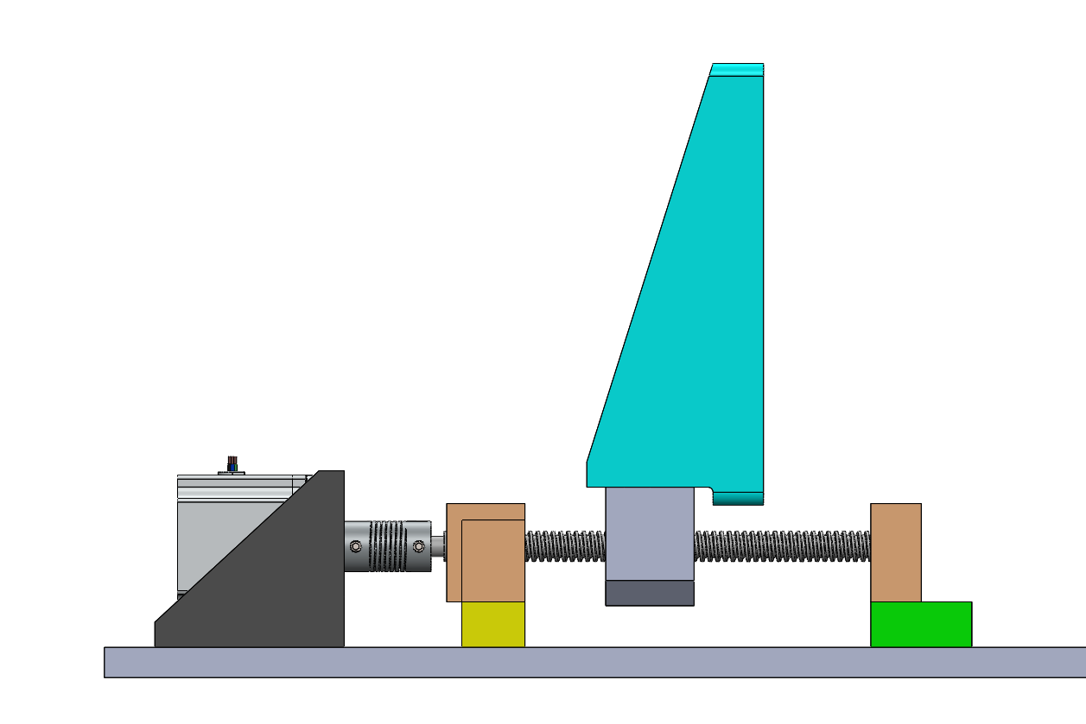

Figure

A side view of the ventilator push-arm assembly is shown above in Figure 1. A similar assembly is mirrored on the right side and a BVM (AMBU-Bag) is centered between the two arms; for convenience, only the left arm is shown and will be analyzed further.

If the push-arm is located at a distance $x=x_{c}$ along the length of the screw and the interface between the screw and the push-arm nut is rigid and neglecting planar deflection, the push-arm displacement is obtained from the screw’s longitudinal displacement as well as the total angular displacement times its pitch or the driving ratio, this is given as follows:

|  |  |  |
| --- | --- | --- |
|  | $$x=x_{c,o}+θ*\frac{P}{2π}$$ | Equation |

Consequently, the velocity is obtained by taking the time derivative,

|  |  |  |
| --- | --- | --- |
|  | $$v=v_{c,o}+ω*\frac{P}{2π}$$ | Equation |

## Power Modelling

The power provided by the motor converts to the work required to compress the BVM. The following equations govern the power dynamics; assuming no losses:

|  |  |  |
| --- | --- | --- |
|  | $$P_{arm}=F*v$$ | Equation |
|  |  | Equation |

Thus,

|  |  |  |
| --- | --- | --- |
|  |  | Equation |

where, F is the force from the push-arm onto the BVM.

In addition, the power from the push-arm is converted to the required flow-rate through:

|  |  |  |
| --- | --- | --- |
|  | $$P_{airway}=p_{airway}*Q=2P_{arm}$$ | Equation |

For more detailed power analysis, refer to the Section 3.4.

## Push-Arm Low-Order-Frequency Drive

This section presents a detailed derivation of the push-arm drive kinematics and dynamics.

The push-arm position can deviate due to quasi-static effects as well as due to resonance resulting from the reactive moments on the push-arm. As a result, these effects are taken in account to develop a dynamics model of the lead-screw and push-arm driving system at a low-order frequency encompassing the distributed inertial effects. Fortunately, the motor mechanics for the ventilator are of low order making it simple enough to use for simultaneous design of mechanical system and the controller. [2]

### Governing Equations

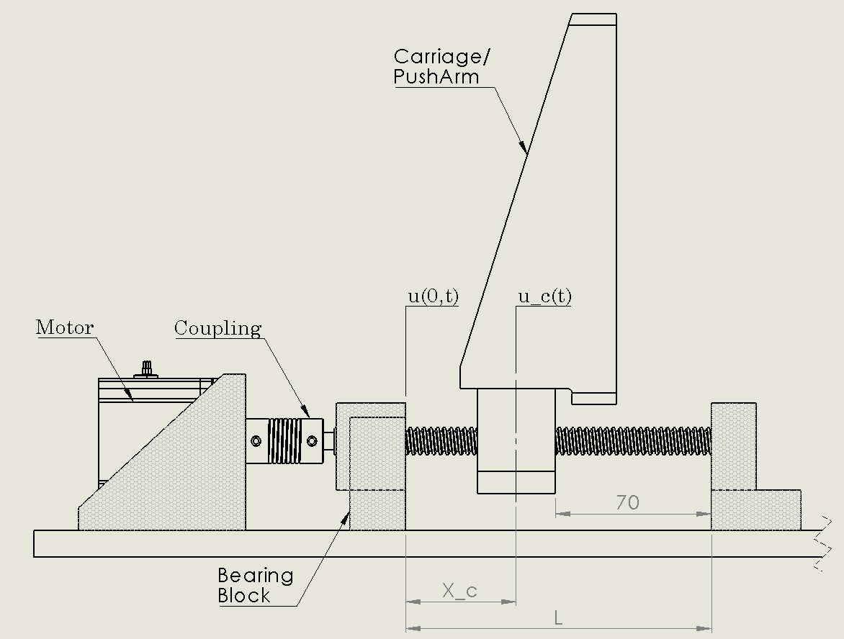

Figure

Considering steady state harmonic vibration of lead-screw drive as shown in Figure 2 at a frequency **w**, the vibratory displacement of the push-arm is given by (in polar coordinates):

$$u_{c}\left(x,ω\right) e^{jωt}$$

and the rotational displacement by the motor is given by:

$$θ\left(x,ω\right) e^{jωt}$$

The longitudinal displacement and angular displacement by lead-screw are both governed by a second-order wave equation [3]; neglecting the effects of the threads on the lead-screw, the longitudinal displacement equation is as follows:

$$E\frac{∂^{2}u\left(x,ω\right)}{∂x^{2}}+ρω^{2}u\left(x,ω\right)=∅$$

and the angular displacement equation is as follows:

$$G\frac{∂^{2}θ\left(x,ω\right)}{∂x^{2}}+ρω^{2}θ\left(x,ω\right)=∅$$

where, $ρ, E \& G$ are density, elastic modulus and shear modulus of the lead-screw, respectively.

### Boundary Conditions

At both ends of the lead-screw, the following Neumann conditions are applied,

$$EA\frac{∂u\left(0,ω\right)}{∂x}=k_{b1}u\left(0,ω\right)$$

$$EA\frac{∂u\left(L,ω\right)}{∂x}=k_{b2}u\left(L,ω\right)=0$$

where, $k_{b1} \& k_{b2}$ are longitudinal stiffnesses of the bearing and the end support, respectively. Since the lead-screw is un-constrained axially at the end support, it is possible to set $k_{b2}=0$.

The twisting moment on the lead-screw at the end support (x = L) vanishes, thus:

$$\frac{∂θ\left(L,ω\right)}{∂x}=0$$

The twisting moment in the lead-screw is the same as in the coupling, thus the relation of rotation at the end of lead-screw to the rotation of the motor is as follows,

$$GJ\frac{∂θ\left(0,ω\right)}{∂x}=k_{c}[θ\left(0,ω\right)-θ_{m}\left(ω\right)]$$

where,

$$G≡Shear Modulus of leadscrew$$

$$J≡average polar moment of inertia of the leadscrew$$

$$k_{c}≡torsional stiffness of coupling between motor and leadscrew$$

$$θ_{m}\left(ω\right)≡rotational velocity of motor$$

### Push-Arm Nut and Lead-Screw

Assuming the lead-screw is perfectly rigid and neglecting planar deflection of threads, the displacement of the push-arm (& nut) is given by (the kinematic equation) initial longitudinal displacement plus the angular twist times the driving ratio (pitch, P) of the lead-screw:

$$u_{c}\left(ω\right)=u\left(x_{c},ω\right)+θ(x_{c},ω)\frac{P}{2π}$$

The interface between the lead-screw and the nut holding the push-arm has an appreciable amount of compliance that should be accounted for in the displacement equation. Given $k_{n}$ as the axial stiffness of the nut, the following equation defines the axial force:

$$F_{n}=k_{n}x_{c}^{+/-}$$

The axial force and the torque developed in the lead-screw are given by the combination of the forces and torques on the portions of the screw to the left and to the right of the nut, resulting in:

$$F_{n}=EA\left[\frac{∂u\left(x_{c}^{+},ω\right)}{∂x}-\frac{∂u\left(x_{c}^{-},ω\right)}{∂x}\right]$$

Thus, the kinematic equation of the lead-screw is re-written as follows,

$$u_{c}\left(ω\right)=u\left(x_{c},ω\right)+\frac{EA}{k_{n}}\left[\frac{∂u\left(x_{c}^{+},ω\right)}{∂x}-\frac{∂u\left(x_{c}^{-},ω\right)}{∂x}\right]+\frac{P}{2π}θ(x_{c},ω)$$

### Motor and Lead-Screw

The motor armature is subject to a twisting moment imposed by the lead-screw onto the coupling, and is given by:

$$k_{c}[θ\left(0,ω\right)-θ_{m}\left(ω\right)]$$

In addition, there is an actuation torque and an effective viscous damping torque acting on the armature of the motor, resulting in the following combined equation:

$$\left(-ω^{2}J_{m}+jωC_{m}+k_{c}\right)θ_{m}\left(ω\right)=T_{m}+k_{c}[θ\left(0,ω\right)$$

where,

$$jωC_{m}θ_{m}\left(ω\right)≡viscous damping torque$$

$$T_{m}≡actuation torque$$

$$J_{m}≡rotary inertia of the motor armature$$

As a result, the push-arm nut is subject to the force exerted by the lead-screw in addition to the two forces: a disturbance force and an effective viscous damping force,

$$\left(-ω^{2}m_{c}+jωC_{c}+k_{n}\right)u_{c}\left(ω\right)=F_{c}\left(ω\right)+k_{n}[u\left(x_{c},ω\right)+θ(x_{c},ω)\frac{P}{2π}$$

### The Dynamic Equation

Assuming the frequency of motion is lower than the time taken of longitudinal waves to travel along the length of the lead-screw, the inertial terms in the given wave equations are very small and can be neglected. This is represented by the inequalities as follows:

$$ωL≪{\left(\frac{E}{ρ}\right)}^{0.5}$$

$$ωL≪{\left(\frac{G}{ρ}\right)}^{0.5}$$

The approximation is then performed using Galerkin-type [4] weighted residual, ***R***:

$$R= θ_{m}\left(ω\right)\left[\left(-ω^{2}J_{m}+jωC_{m}+k_{c}\right)θ_{m}\left(ω\right)-T_{m}-k_{c}θ\left(0,ω\right)\right]+u_{c}\left(ω\right)\left[\left(-ω^{2}m_{c}+jωC_{c}+k_{n}\right)u_{c}\left(ω\right)-F_{c}-k_{n}\left(u\left(x_{c},ω\right)+θ\left(x_{c},ω\right)\frac{P}{2π}\right)\right]-\int_{0}^{L}{u\left(x,ω\right)\left[E\frac{∂^{2}u\left(x,ω\right)}{∂x^{2}}+ρω^{2}u\left(x,ω\right)\right]dx-}\int_{0}^{L}{θ\left(x,ω\right)\left[G\frac{∂^{2}θ\left(x,ω\right)}{∂x^{2}}+ρω^{2}θ\left(x,ω\right)\right]dx}$$

The following equation can be modelled in Matlab Simulink to precisely study the kinematics of the BVM compression mechanism.

## Area Calculations

### Rectangular approximation

With rectangular approximation, the contact area of push-arm sits flush with the BVM. The area is approximated using the equations below:

$$A_{c}=\frac{2}{3}b*h$$

where *b* and *h* are breadth and height of the push-arm.

### Cylindrical approximation

A more accurate estimate of the area is obtained using Hertz equation. As the push-arm pushes against the BVM, the contact area gradually increases. This is directly related to the deformation force applied as well as the material properties of both push-arm and BVM.

The equations are as follows:

$$A_{cont}=2a*b$$

$$a=\frac{2FR_{BVM}}{πE^{*}}$$

$$E^{*}=\frac{1-υ_{S}^{2}}{E_{S}}+\frac{1-υ_{BVM}^{2}}{E_{BVM}}$$

where,

$$b=width of Pusharm$$

$$R_{BVM}=equivalent centre radius of BVM$$

$$υ_{S}=poisson ratio of Pusharm \left(ABS / PLA if 3DP\right)$$

$$υ_{BVM}=poisson ratio of BVM (AMBU Bag)$$

## Design Validation

### Explicit Modelling

Explicit modelling is performed using silicone-based BVM and PLA-based Push-Arms – two parameters are studied: frequency of harmonic during travel and stresses developed during compression.

The initial conditions and boundary forces applied are based on I:E ratio of 1:2, Breaths-per-minute of 15 [bpm], tidal volume of 800 [ml], resulting in a linear velocity of 26 [mm/s] based on a standard lead-screw pitch of 5 [mm/rev]. The force obtained from one push-arm is approximately 55 [N].

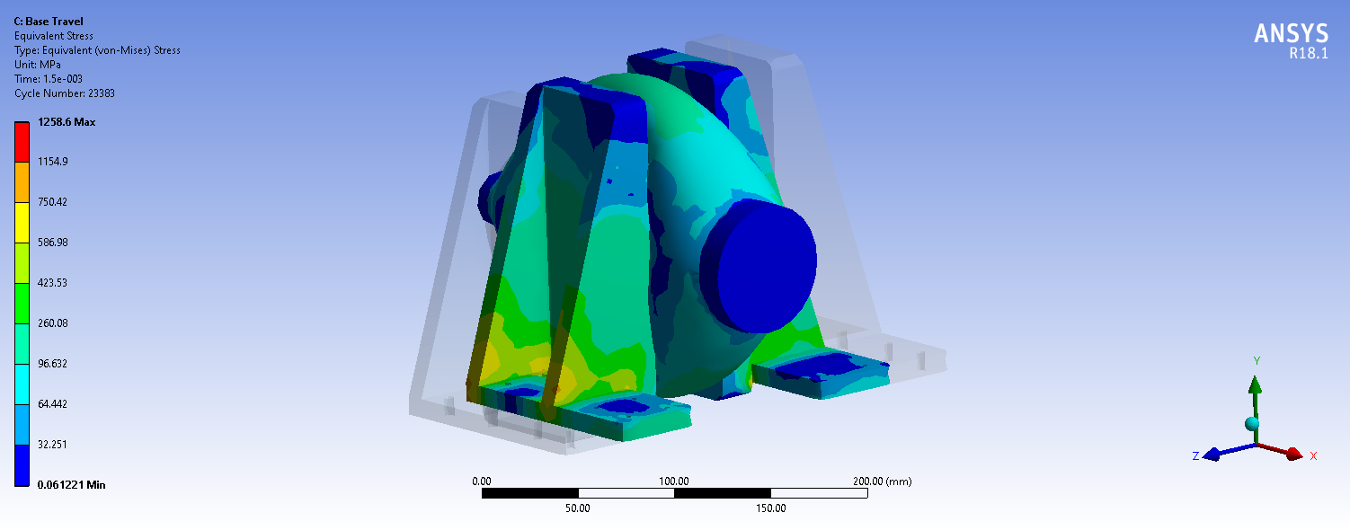

Figure

A cycling rate of 23,383 x2 is obtained before fatigue with a safety factor of 2; this translates to ~52 operational hours with a BPM of ~15. As a result, it is expected that the BVM will be replaced every other day in order to comply with safe and accurate usage of the ventilator.

Refer to the [.wbj] file for detailed analysis.

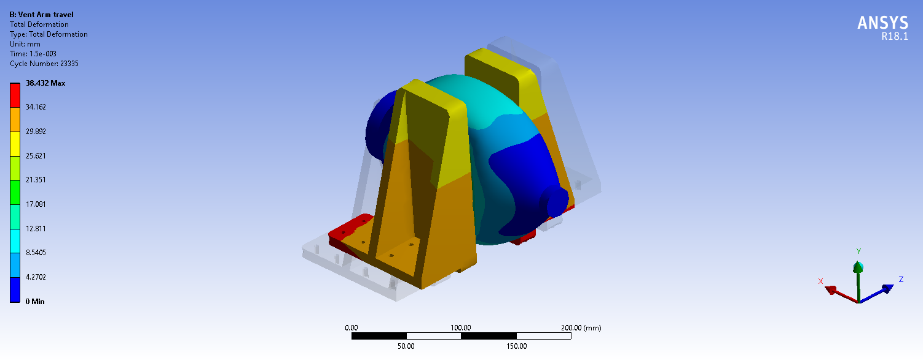

Figure : Deformation analysis

Figure : Maximum Displacement from Push-Arms based on given conditions

# OpenLung Concept-7 – Mathematical Model

## Kinematics (Case A: Unhinged Lever)

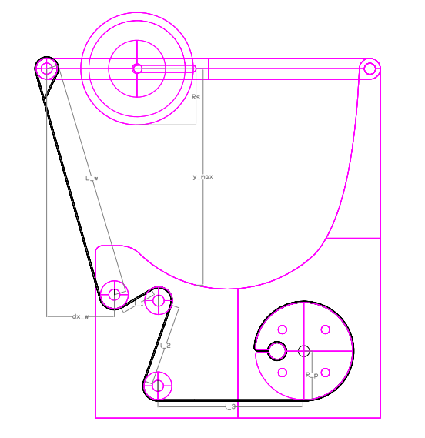

Figure

Assuming linearity and establishing cartesian kinematics, the geometry above provides the equation:

$${θ°}_{M}=\frac{180(y_{max}-R_{S})}{πR_{M}*cos⁡(α_{web})} [Deg]$$

where,

$$α_{web}= \sin^{-1}\left(\frac{dx_{w}}{L_{w}}\right)=16.67°$$

$$R_{S}=Radius of Sticky Roller$$

$$R_{M}=Radius of Motor Roller$$

Since the sticky roller is free to roller, we can neglect large adhesion; hence, approximating using Hertz’s equation, and assuming incompressibility for the given temperature and pressure withing BVM, the following equations can be used to estimate the belt velocity and hence the required angular velocity from the time derivation of angular displacement equation; assuming steady state and RBVM >> RS :-

where,

$$Q_{BVM}=Volumetric flow rate from BVM$$

$$w_{S}=width of sticky roller$$

$$A_{cont}=Contact area$$

$$a=\frac{4FR_{S}}{πE^{*}}$$

where,

$$F=m_{s}g=ρ_{s}*∀_{s}*g=ρ_{s}*g*\left(πR_{S}^{2}\right)*w_{S}$$

$$E^{*}=\frac{1-υ_{S}^{2}}{E_{S}}+\frac{1-υ_{BVM}^{2}}{E_{BVM}}$$

where,

$$υ_{S}=poisson ratio of sticky roller \left(ABS / PLA material if 3DP\right)$$

$$υ_{BVM}=poisson ratio of BVM (AMBU Bag)$$

The equations above can be re-written as:

$$2a=\frac{8ρ_{s}g*\left(πR_{S}^{3}\right)*w_{S}}{πE^{*}}$$

$$A_{cont}=\frac{8ρ_{s}g*\left(πR_{S}^{3}\right)*w_{S}^{2}}{πE^{*}}$$

thus, the rotational/ angular velocity at the motor is given by:

$$v_{b}=R_{M}\frac{dθ}{dt}$$

$$ω_{M}=\frac{v_{b}}{R_{M}}$$

where,

$$v_{b}=approx. belt velocity$$

Given the time duration for inspiration, the angular acceleration of the motor can be approximated as:

$$α_{M}=\frac{ω_{M}}{t_{isnpiration}}$$

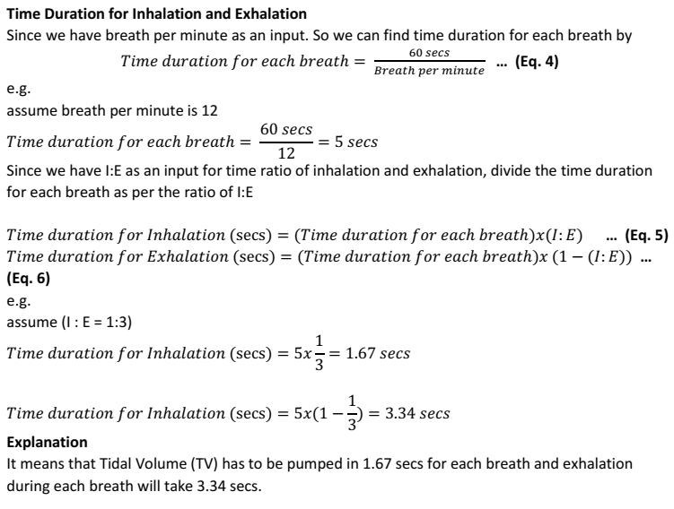

Figure

## Kinematics Modeling (Case B: Hinged Lever)

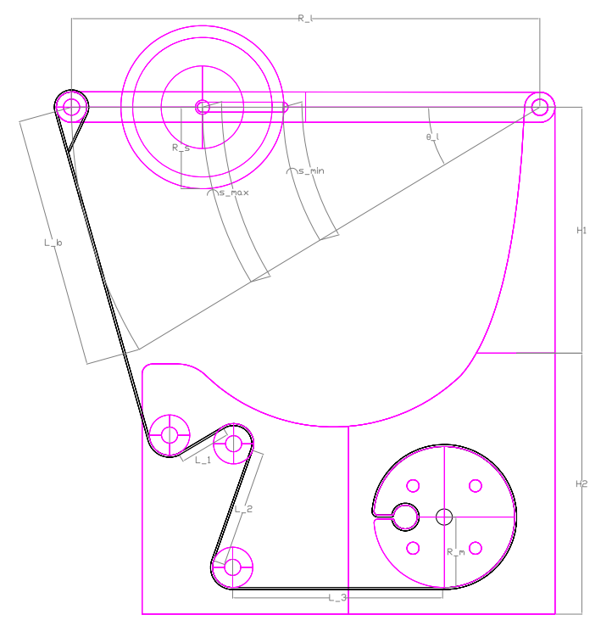

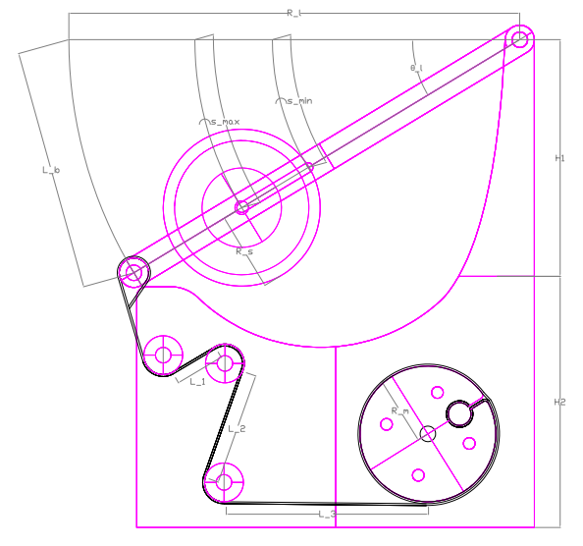

Figure and Figure

Referring to the geometry above, and assuming the belt, rigid, stays taut throughout its travel, the following equations can be used to estimate the angular displacement and thus the angular steps by the stepper-motor:

$$L_{b}=\frac{R_{l}*\sin{(θ_{l})}}{\cos{({θ_{l}}/2})}$$

$${θ°}_{M}=\frac{{180L}_{b}}{{πR}_{M}} [Deg]$$

where,

$$R_{l}=length of the lever arm$$

$$θ_{l}=angular displacement of lever arm$$

$$L_{b}=length of linear belt travel$$

$$S_{min/max}=linear compression of BVM=R_{l, min/max}*θ_{l}$$

$$R_{M}=radius of motor roller$$

$${θ°}_{M}=angular displacement by stepper motor$$

Since the sticky roller is free to roller, we can neglect large adhesion; hence, approximating using Hertz’s equation, and assuming incompressibility for the given temperature and pressure withing BVM, the following equations can be used to estimate the belt velocity and hence the required angular velocity from the time derivation of angular displacement equation; assuming steady state and RBVM >> RS :-

where,

$$Q_{BVM}=Volumetric flow rate from BVM$$

𝑤𝑆=𝑤𝑖𝑑𝑡ℎ 𝑜𝑓 𝑠𝑡𝑖𝑐𝑘𝑦 𝑟𝑜𝑙𝑙𝑒𝑟

$$A_{cont}=Contact area$$

$$a=\frac{4FR_{S}}{πE^{*}}$$

where,

$$F=m_{s}g=ρ_{s}*∀_{s}*g=ρ_{s}*g*\left(πR_{S}^{2}\right)*w_{S}$$

$$E^{*}=\frac{1-υ_{S}^{2}}{E_{S}}+\frac{1-υ_{BVM}^{2}}{E_{BVM}}$$

where,

$$υ_{S}=poisson ratio of sticky roller \left(ABS / PLA material if 3DP\right)$$

$$υ_{BVM}=poisson ratio of BVM (AMBU Bag)$$

The equations above can be written as:

$$2a=\frac{8ρ_{s}g*\left(πR_{S}^{3}\right)*w_{S}}{πE^{*}}$$

$$A_{cont}=\frac{8ρ_{s}g*\left(πR_{S}^{3}\right)*w_{S}^{2}}{πE^{*}}$$

thus, the rotational/ angular velocity at motor is given by:

$$v_{b}=R_{M}\frac{dθ_{M}}{dt}$$

$$ω_{M}=\frac{v_{b}}{R_{M}}$$

where,

$$v_{b}=approx. belt velocity$$

Given the time duration for Inspiration, the angular acceleration of the motor can be approximated as:

$$α_{M}=\frac{ω_{M}}{t_{isnpiration}}$$

*For Inspiration time calculation, see Figure 7 in section 3.1.

## Discretizing the Pressure force

### Method of Finite Differences

Given that, as the motor accelerates, the angular velocity of lever changes; thus, the pressure force from the sticky-pressure roller onto the BVM changes accordingly.

The Torque from the motor roller is as follows:

$$τ=TR_{M}=I_{M}α_{M}$$

$$T=\frac{I_{M}}{R_{M}}α_{M}$$

Recalling the equation, from which the Force, F can be rewritten, assuming no other force acts on the lever, as:

$$a=\frac{4FR_{S}}{πE^{*}}$$

$$F=m_{s}g+T$$

The component T of force changes as per the discretized equation below:

$$T_{i+1}=T_{i}+k\frac{∆T}{∆t}(ω_{i}-ω_{i-1})$$

where and for,

$$i=1,2,….$$

$$k=\frac{I_{M}}{R_{M}}$$

At start, the roller is resting on the BVM, thus the following initial conditions are applied:

$$T_{1}=0$$

$$ω_{i}=0$$

The above equations can be iterated alongside the equations in Section 1 & 2 for a close estimate of force and pressure requirements at the BVM.

### Planar Area Estimation

A more simplified estimation is obtained using finger-bag contact, the finger lever arm length and the sweep angle. This is presented directly from the MIT E-VENT Manual. [5]

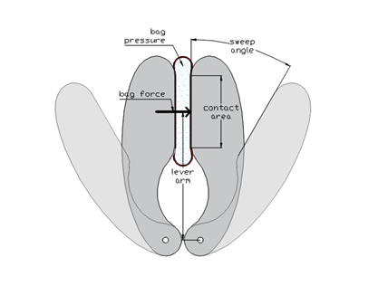

Figure

* Finger-bag max contact area: *A*bag = 80 mm2
* Finger lever arm length: *l*finger = 12 cm
* Sweep angle: αsweep = 30°

The maximum force of the bag on one finger (when fully squeezed) is, using the same 50% pressure transmission efficiency as before:

$$F_{finger}=A_{bag}*\frac{p_{airway, max}}{0.5}=50.2 N$$

## Breath Analysis and Power Modelling

Given a required Tidal Volume and Respiratory Rate (bpm), the Minute Volume is calculated as follows,

$$MV=V_{T}*{R_{R}}/{60}$$

For a given I:E ratio, the required Inspiratory flow-rate is then,

$$\sum{\left(I:E\right)}=I+E$$

$$Q_{BVM}=MV*\sum{\left(I:E\right)}$$

For a specific ideal gas at a given pressure and volume, the constant energy equation is given by,

$$E=p*V=mRT=\frac{V^{2}}{C'}$$

Taking the time derivative provides the necessary power equation,

$$P=p*Q=\dot{m}RT$$

Thus, the total power can be estimated by the equation,

$$P=\frac{(PIP)*Q_{BVM}}{η_{inspiration}{*η}_{Mech}*η_{Elec}}$$

where,

$$η_{inspiration}≡Inspiration Efficiency$$

$$η_{Mech}≡Mechanical Efficiency$$

$$η_{Elec}≡Electrical Efficiency$$

The power at the electrical connection can be estimated by:

$$P=Voltage*Current=∀*I$$

The power at the motor can be estimated by:

$$P=Torque*Angular Speed=τ*ω$$

The power at the BVM can be estimated by:

$$P=Force by compression*Velocity=F*ν$$

The power values can then be summed alternatively to obtain the total power.

## Design Validation

### Explicit Modelling

Results are obtained by modeling the pressure roller and ring, rigid, and using Polyethylene as material. The BVM is modeled as silicone-type 1.5L model (based off OpenLung model).

The conditions include a ramping-up velocity and an initial force - the target results are potential deformation and stresses obtained.

Figure : Deformation Curve

Figure : Stress Curve

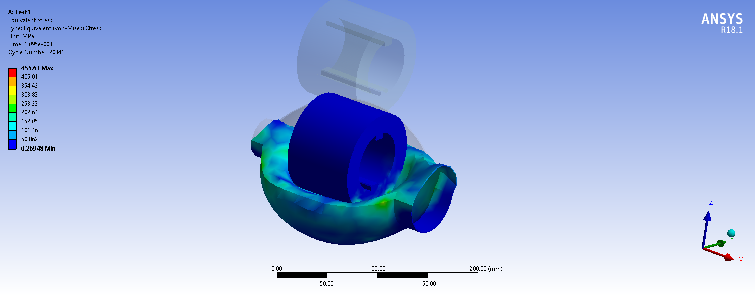

Figure : Octahedral Stresses

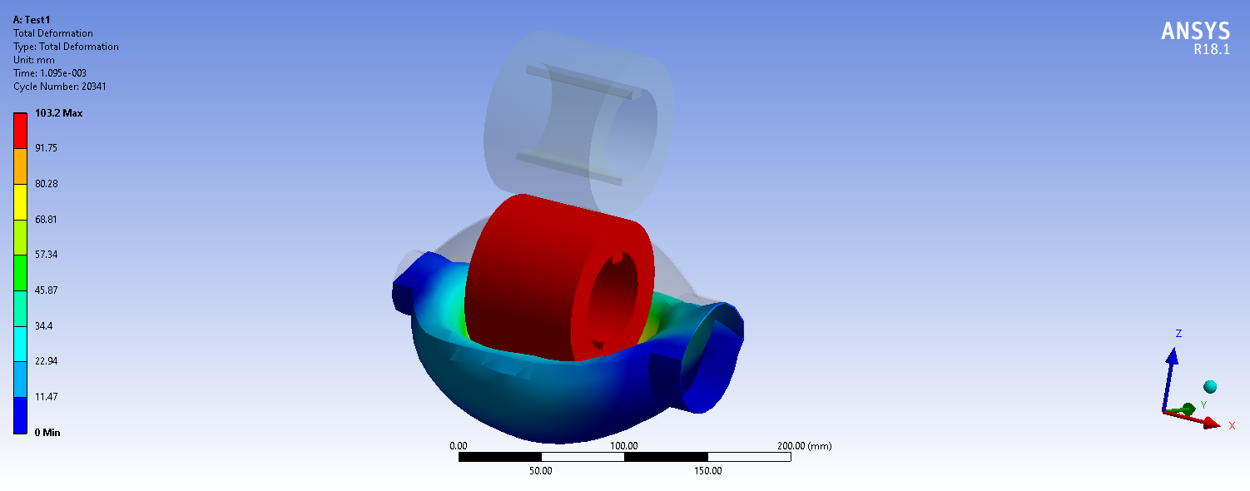

Figure : Deformation analysis

# References

|  |  |
| --- | --- |
| [1] | O. PAC-V, "OpenVentPk Manual," Pakistan, 2020. |
| [2] | J. T. Y. Chen, "Effect of low-friction guideways and lead-screw flexibility on dynamics of high-speed machines," Annal of the CIRP, 44, //, 1995, pp. 353-356. |
| [3] | S. Nayfeh, "Design and Application of Damped Machine Elements," Massachusetts Institute of Technology, Cambridge, Massachusetts, 1998. |
| [4] | CalTechAUTHORS, "Boundary-Value Problems for Ordinary Differential Equations: FEM," //. |
| [5] | M. E.-V. Team, "MIT E-Vent Information (30/03/2020)," 2020. |
| [6] | N. MacIntyre, M. Nishimura, Y. Usada, H. Tokioka, J. Takezawa and Y. Shimada, "The Nagoya Conference on System Design and Patient-Ventilator Interations During Pressure Support Ventilation," Chestnut, 2017. |
| [7] | Unknown_Author, "Ventilator Design - mechanical design v1," 2020. |

|  |  |  |  |
| --- | --- | --- | --- |
| Version # | Date | Changelog | By |
| V0 | 24-Apr-2020 | Creation | OpenVentPk |
| V1 | 27-Apr-2020 | First Issue | OpenVentPk |
| V2 | 05-May-2020 | Addition and Modifications  - Area Calculations  - Validation results | OpenVentPk |
|  |  |  |  |
|  |  |  |  |
|  |  |  |  |
|  |  |  |  |